Motorized Scooter Project

1. The aim of this document is to gather the sum of photo documentation of the electric scooter project and provide commentary and notes on the build process.

The initial aim of this project was to acquire a 6061 aluminum u-channel, attach the front end of a razor scooter to the front of it, and then motorize the construction.

The original plan was to use the traditional small “kick scooter” for the front end, as it was detachable. However, since that scooter seemed far too small for my body size, I opted to use the larger A5 Lux. And while it was larger, the front end “pivot” was also welded on. As a result, I was forced to CAD replacement front attachments and mill them out.

1. **Mechanical**

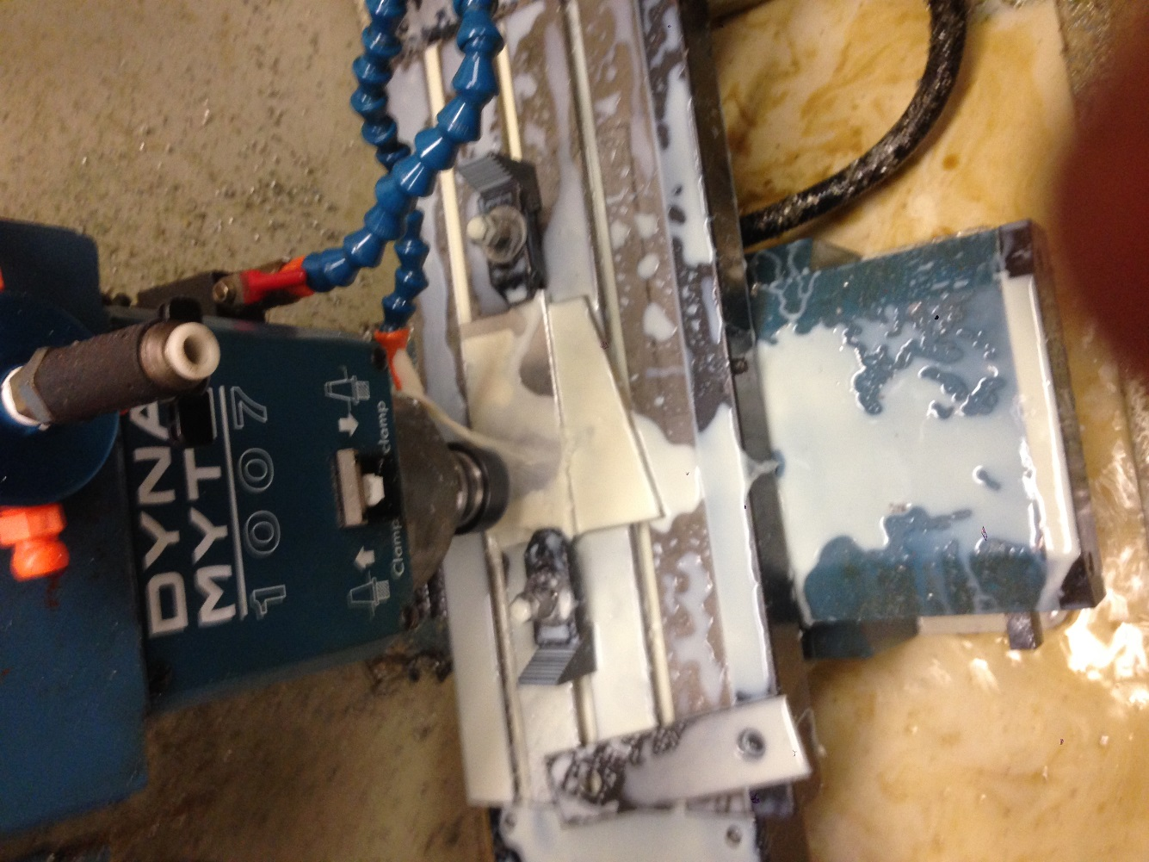

The final pivot looked like this. Unfortunately, the pieces were made too shallow, and thus the scooter leg had to be sanded down in order for it to be properly collapsable.

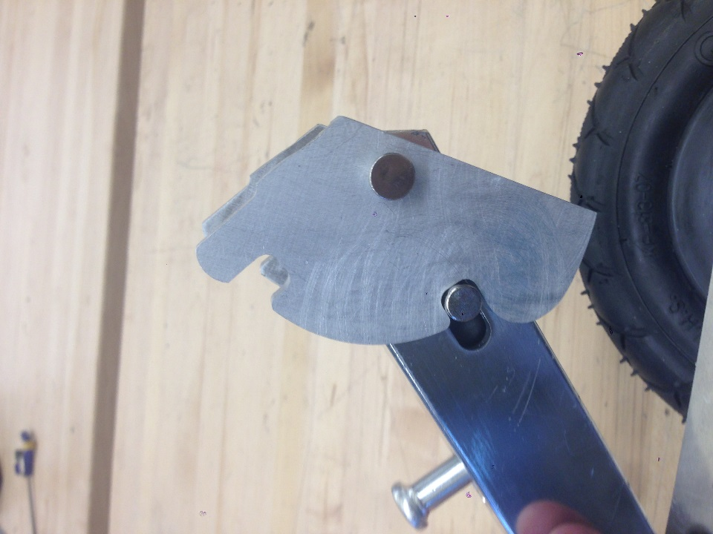

Another problem arose in the length of the attachment leg itself. As seen in the below photo, the leg stretches to reach the bottom of the front wheel assembly. As a result, if this was mounted on a scooter base with any appreciable height, the wheel would be unable to touch the ground. Drastic measures had to be taken to achieve proper dimensionality.

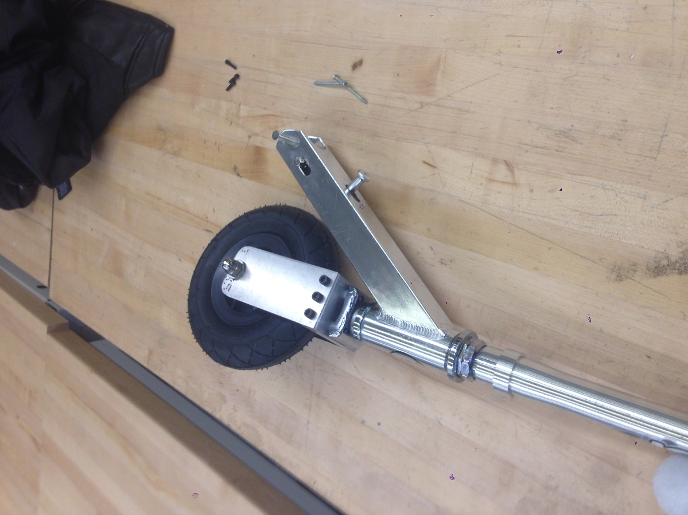

By bandsawing the assembly apart, and cutting off an appreciable amount, I was able to weld the whole thing back together. This preserved the superior height, angle, and collapsing mechanism of the LUX A5 scooter, but mitigated the previous problem.

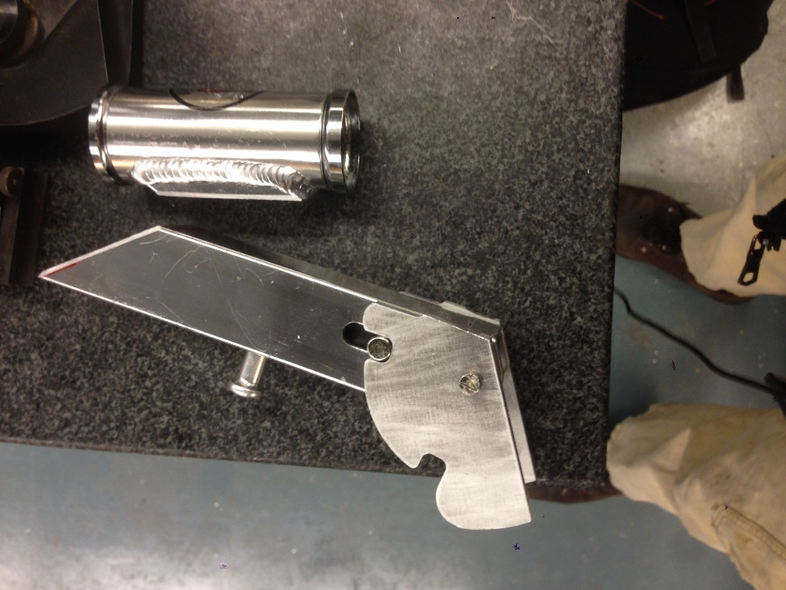

Work on the u-channel itself was rather simple. Space was cut out of the back for the rear wheel assembly, and the pivots were welded on.

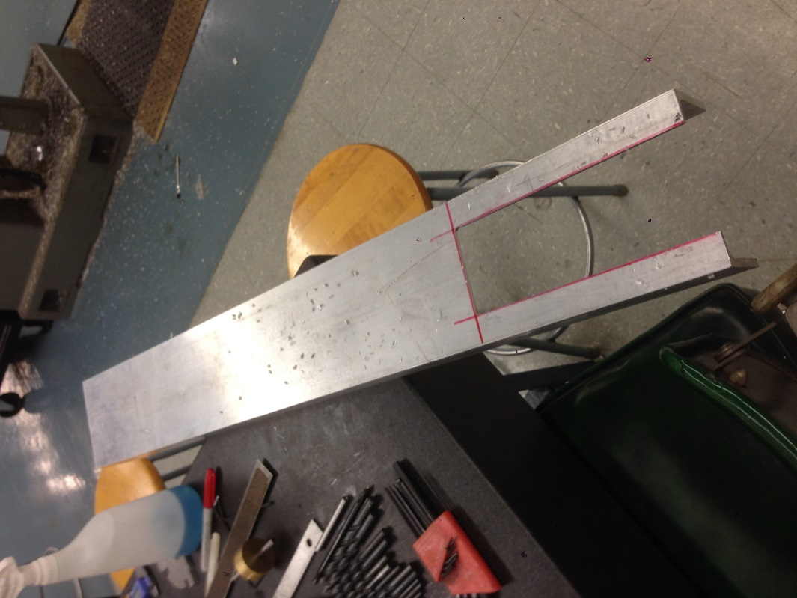

Assembled, the basic mechanical structure of the scooter looked like thus.

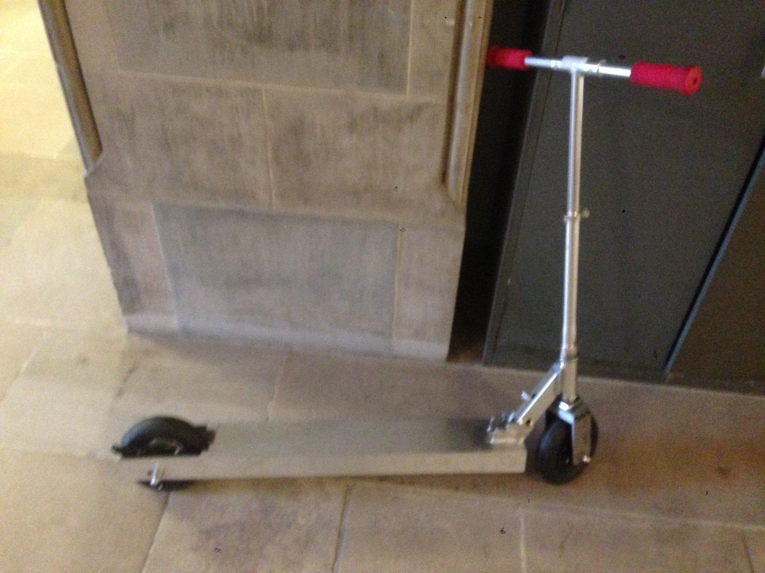

1. Electromechanical Integration

The motor controller that was utilized, by the recommendation of several mentors and friends of mine,[1] was a Chinese product affectionately dubbed the “Jasontroller” after the vendor in China that sold them. They were surprisingly effective sensorless DC motor controllers that were able to, through some sorcery, start a BLDC from standstill rather effectively, even under a considerable load.

The motor that was utilized was a Turnigy SK-3 model airplane BLDC acquired, again, from China. These motors are remarkably energy dense and extremely powerful for their size. My particular make was 200KV 2kW motor, more than sufficient for the roughly 350-500W maximum output of the motor controller. Note that even though it is rated for 2kW, these ratings only really apply accurately for its intended function – smaller load model airplane operation. Fortunately, the large gap in power ratings meant that there was sufficient buffer space for the motor to function effectively under

Finally the battery pack that was used was a bunch of salvaged LiFePO’s that I found in the back room of MITERS, an MIT hackerspace. They were all confirmed to be healthy, at the nominal 3.3V. (Although there were no shortage of dead cells in the box.) I assembled 20 of them in a 10S 2P configuration for 33V at a decent capacity. This allowed for the battery pack to be small enough to fit inside the scooter while not being too energy deficient.

The picture below is the Jasontroller in all of its exposed glory. Most of the connections were unnecessary for the primary function of the scooter – electronic brake, max speed control, etc. Since I intend to implement physical braking and max speed isn’t really an issue all but the enable wires, 3-phase, and throttle signals were excised for space considerations. I also dabbed extra solder on current limiting element leading to the 3-phase in order to increase theoretical maximum current output.

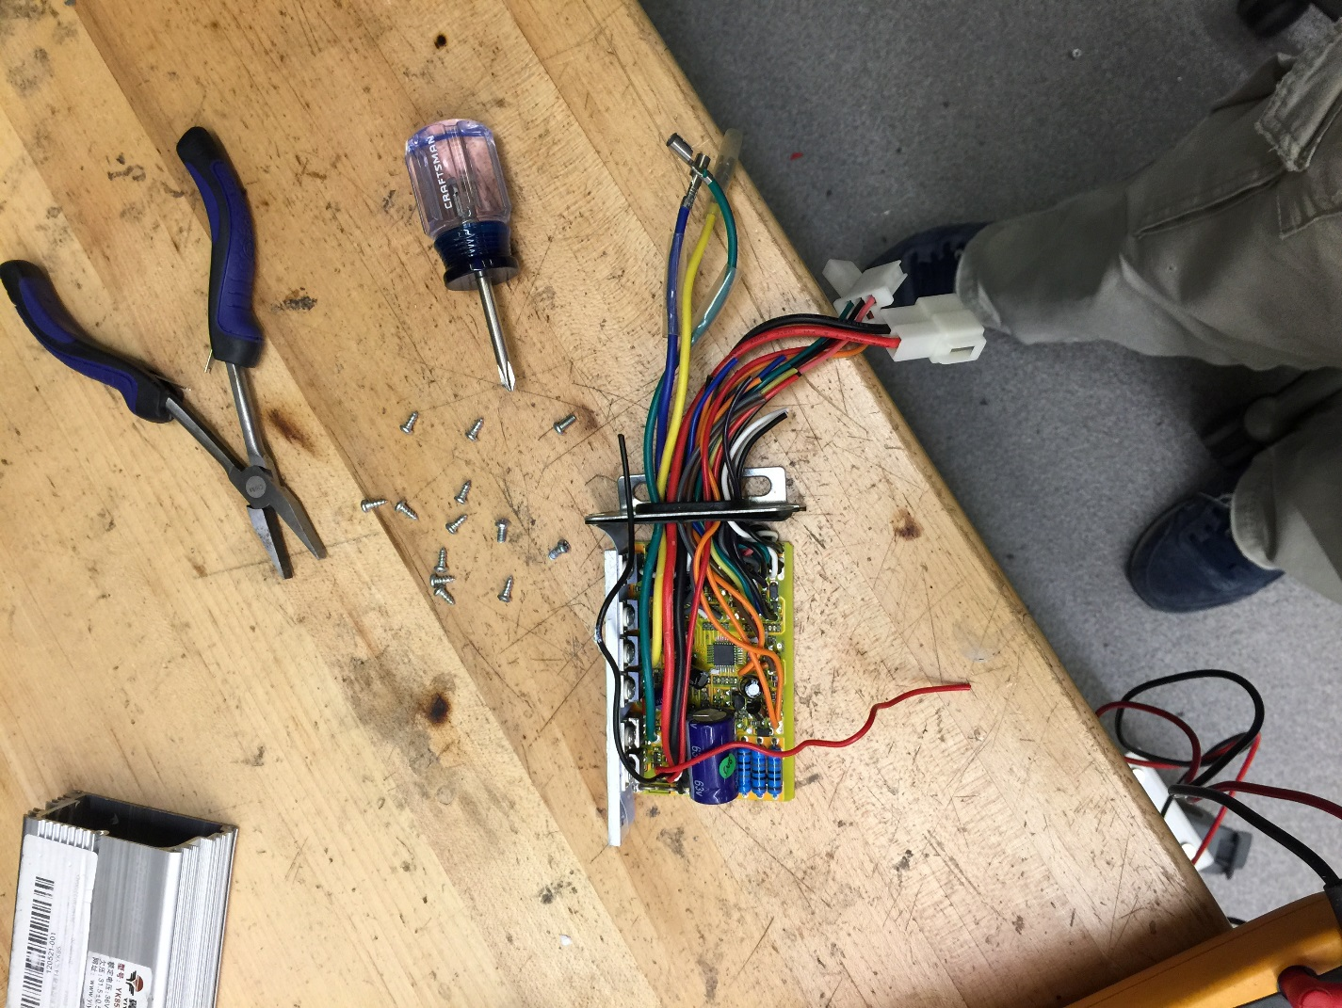

The battery pack itself had balance charging wires attached all over, and output leads soldered to it, after which it was shrink wrapped with some plastic acquired from the most reputable source of all plastics – Schweppes Ginger Ale 20 oz. bottles.

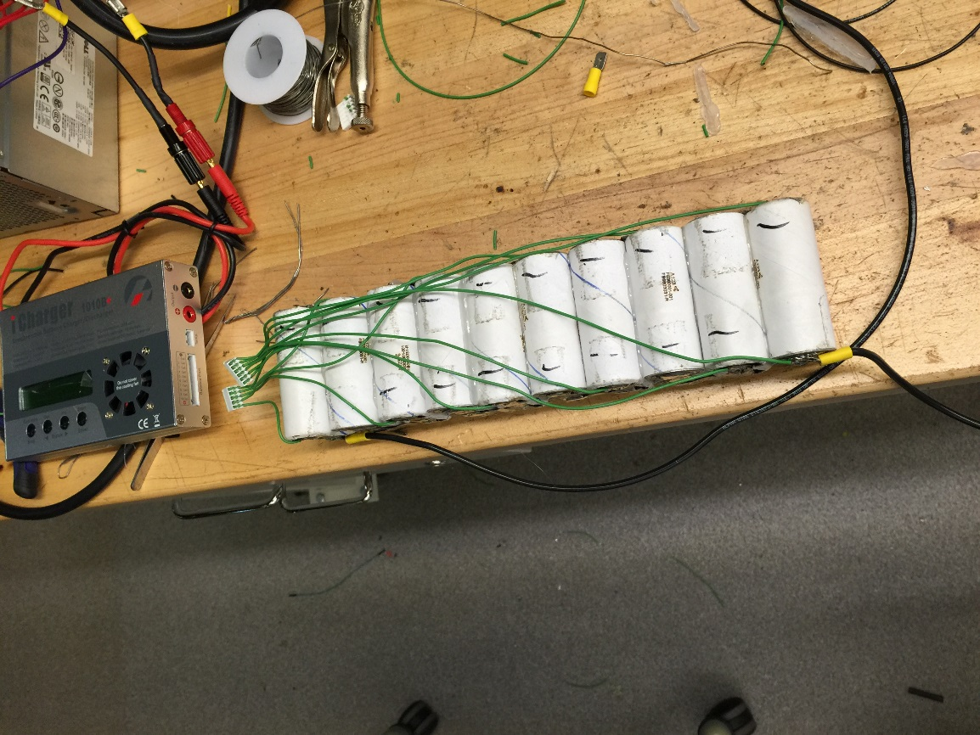

The motor was mounted,

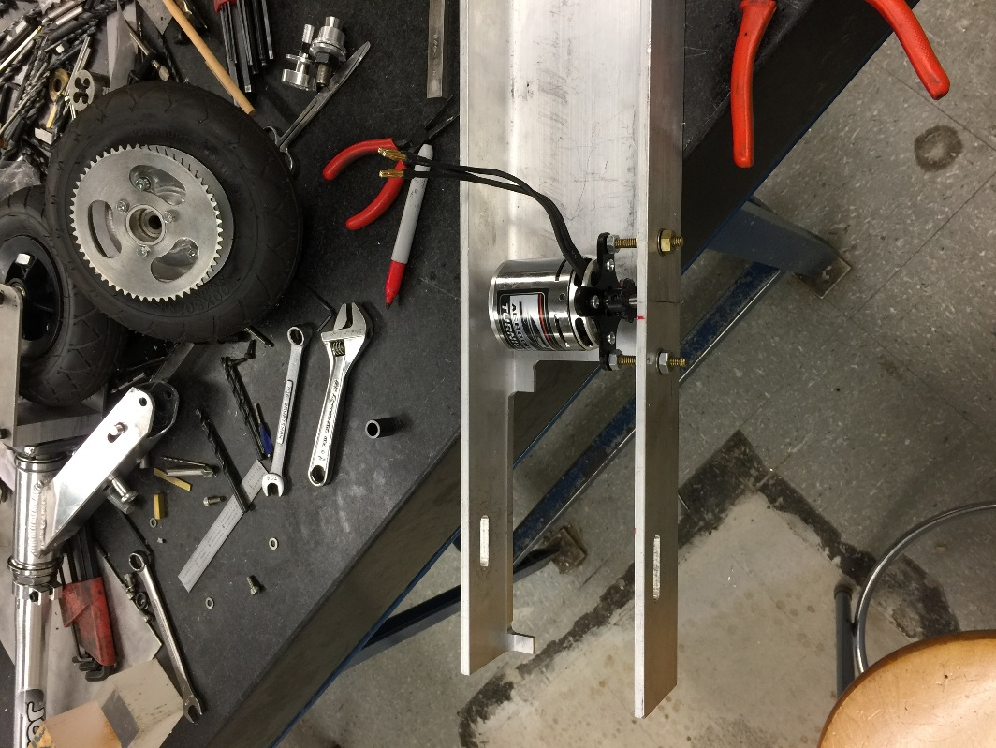

And the whole apparatus was thrown together. Note the third mounting point added to the motor for better stability, and the Anderson connectors that I used instead of the provided connectors for better power connection. Also the green covering over the battery? Schweppes.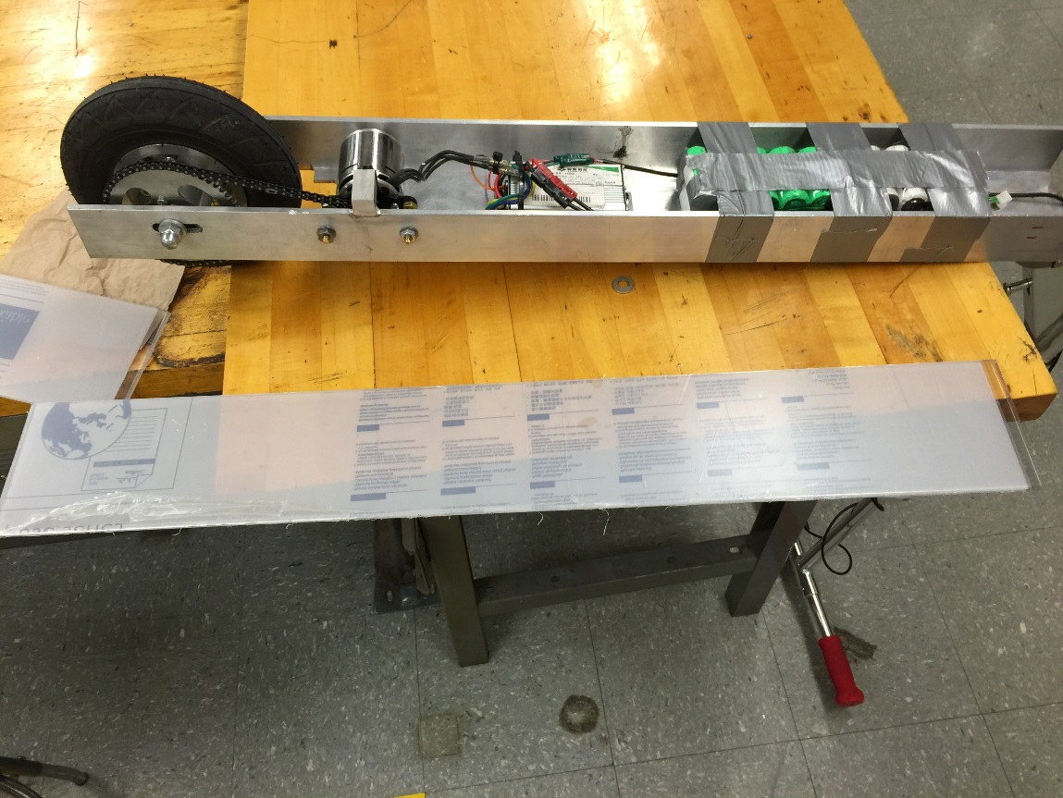

Finally, it was time to seal the whole thing up. Two ideas were thought of. The first was to use a sheet of Lexan to cover the bottom. Unfortunately, the insulation over the battery pack brought an unfortunate amount of extra space, and the Lexan was unable to fit flush over the u-channel. Thus, sheet aluminum was taken, and bent in order to cover the majority of the chassis bottom.

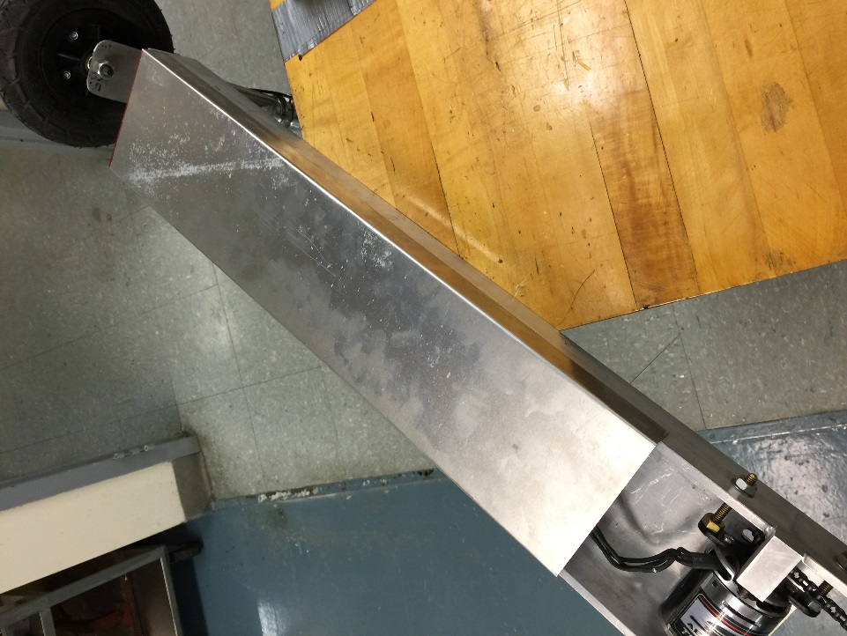

Finally, a rather strangely shaped piece of sheet aluminum was cut out in order to provide protect for the motor and wheel assembly.

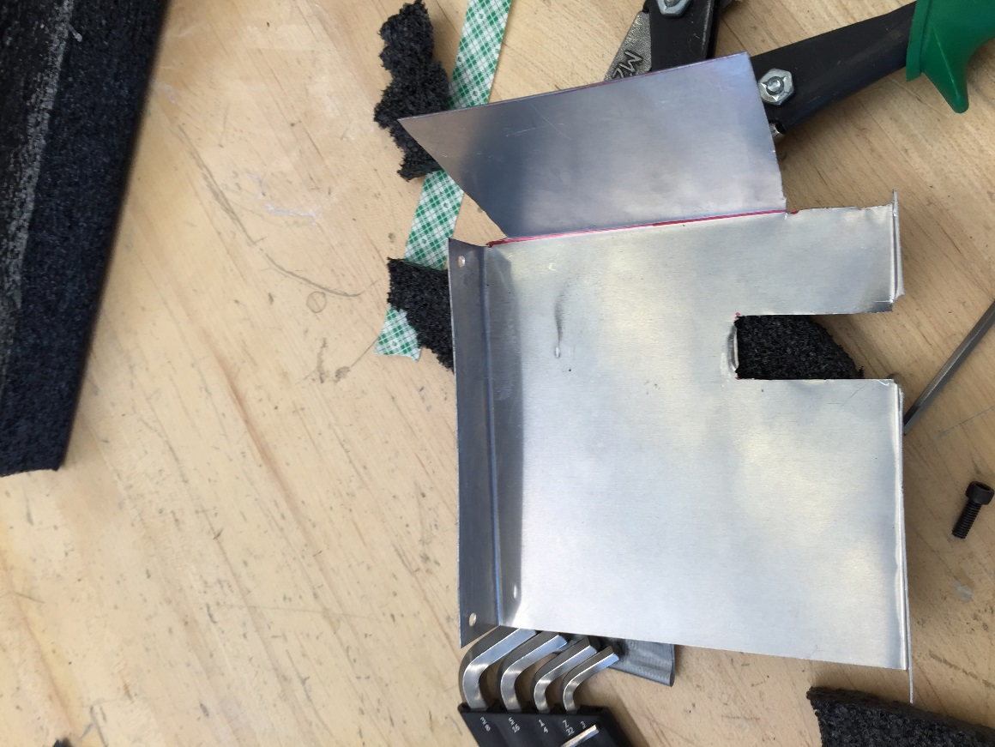

It provided dirt shielding for the motor, and a slot for the third mounting slot to fit in. After this, the whole thing was put together and sealed with bolts and some silicone.

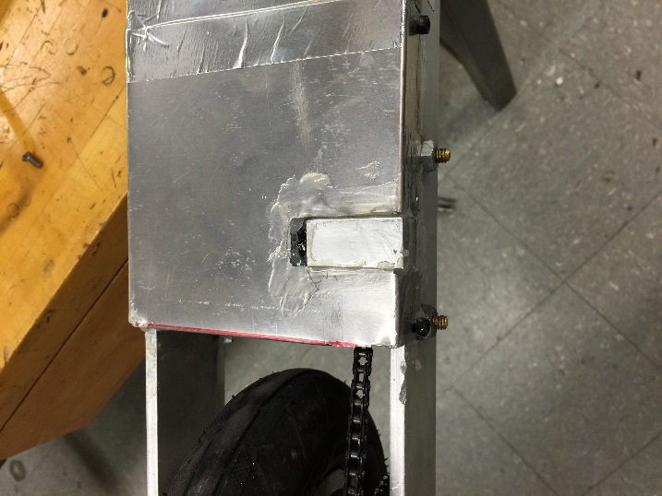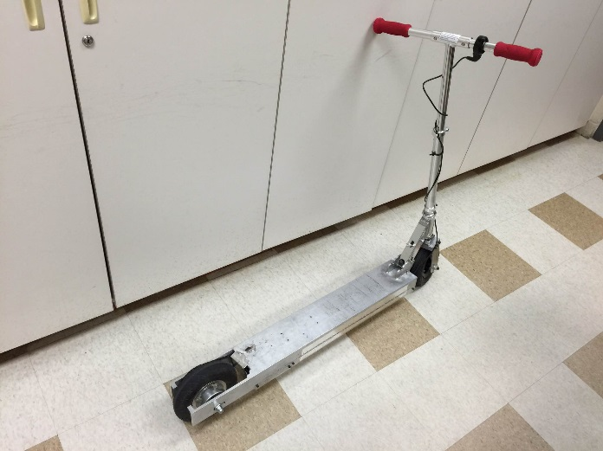

And thus, the scooter was completed!

1. Charles Guan – [www.etotheipiplusone.com](http://www.etotheipiplusone.com) Noel Hwang – hellobowtie.blogspot.com